Question – Account class
A simple bank account class is shown. Draw a state diagram to represent the things that can happen to instances of the class over its lifetime.

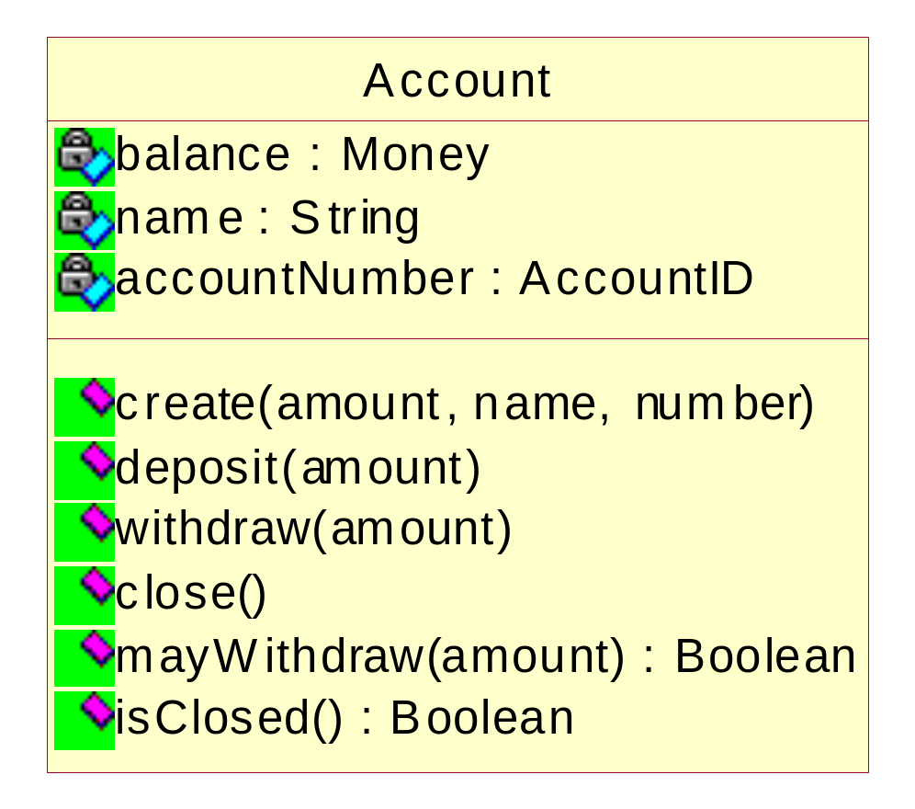

Tennis Scorer
The diagram shows a small gadget for recording tennis scores for games only. The gadget does not score sets or anything really complicated like tie-breaks.
The left button increments the score for the left hand player by a point and the right hand button does the same for the right hand player. The button on the top resets the score back to 0-0 (Love all). When one player has an advantage point the gadget displays an A for that player.
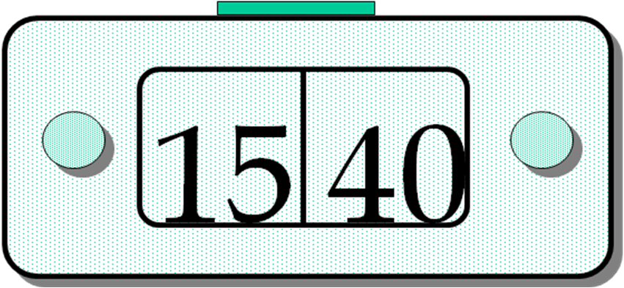

Pop up watch

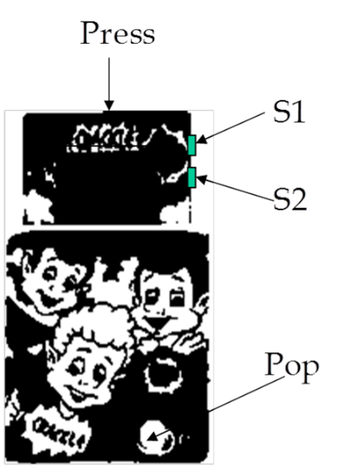
Setting the watch is carried out using the S1 and S2 buttons.
S1 puts you into flashing mode, a further press puts you into setting months. Pressing S2 increments the value on display.Then we move in a similar manner through days hours and minutes.
Pop makes the watch visible and Press can hide it an any time.

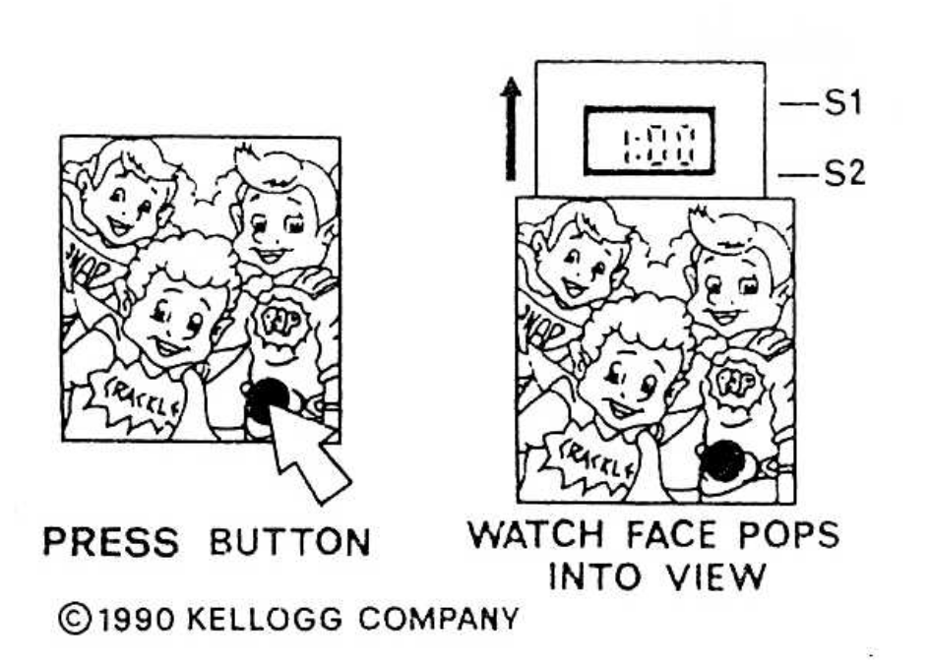
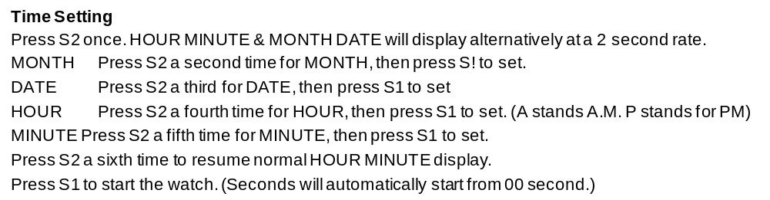

Photocopy card control system
Users are issued with credit card sized cards with a magnetic strip, the magnetic strip contains all the information associated with the card. Each card has a number of credits installed, each credit is for one photocopied sheet. The cards are disposable and pre-loaded with values of; 10, 25, 50, 100, 500, 1000.
The user inserts the card into the machine and, if it has any credits, is allowed to use the photocopier. Each sheet copied decrements the number of credits stored on the card by 1.
A primitive security system is also provided whereby each card may be encoded with a Personal Identity Number. This does not prevent people nicking the card, but you have the satisfaction of knowing that they cannot use it. Also, if you lose your card, and, provided you have written your name on the card, a finder is encouraged to return it.
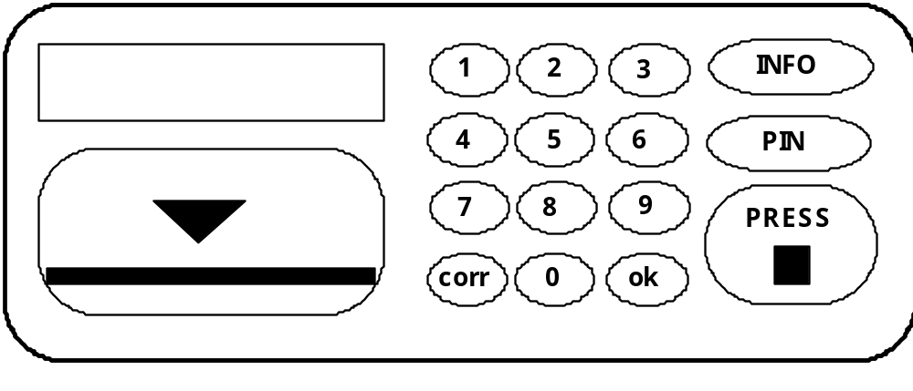
A card is PIN-encoded by pressing the PIN button followed by 4 digits.
The card insertion slot is on the bottom left, depressing the button marked PRESS ejects the card.
The nine element display is on the top left, it usually displays the current credit total on the inserted card but also displays messages.
The PIN button is for encoding each card as outlined earlier.
The INFO button pages through a number of items of information for the service engineer about machine usage etc.
The CORR button allows you to re-key a complete, or a partial, personal identity number. You are only allowed 3 tries at this before it ejects the card.
The OK button is used to confirm that you have finished either, creating a PIN or entering an attempted PIN.

Microwave
The diagram below shows the control panel for a microwave oven. The following notes describe the process of operating the oven.

In normal use the user will open the oven door, place the items to be cooked inside the oven and then close the door. The user then selects the power level at which the cooking takes place. The selected power level is displayed by initial letter in the top left-hand corner of the display area.
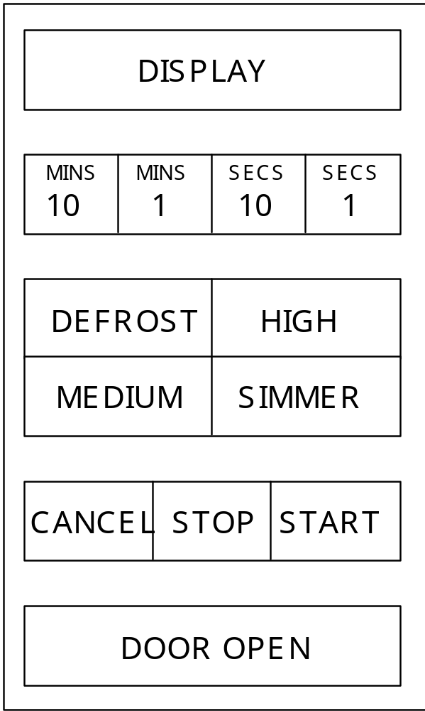
Next, the user selects the cooking time by keying in the required amount of minutes and seconds from the timing keypad. The time is confirmed by pressing the start button, which also starts the cooking.

Other considerations
If at any point during the cooking the user presses the stop button then cooking is suspended and may only be resumed by pressing the start button. Cooking is resumed at the same power level and will only carry on for the remaining programmed cooking time. If the user wishes to amend either the cooking power level or the cooking time then they must cancel the display and start again. Similarly, if the user opens the door then cooking is suspended and may not be restarted until the door is closed.
Draw a statechart diagram for the control of the oven.

